Proposal: Mix District Elections to Improve Representation on Everett City Council
Submitted by: Megan Dunn, with support from citizens
Date: September 28, 2015

The city of Everett would benefit from an increase in diversity on the City Council. As seen with other at-large electoral systems, many residents feel the city council members are not accessible and less responsive to those not adequately represented by the current electoral system (Compton, 2003). Lack of representation by the southern region of the city and a lack of diversity in socio-economic status, class, gender, ethnicity and race are seen as a root cause of apathy. Apathy has resulted in low voter turn out, uncontested elections and limited citizen involvement.

While advancements have been made to increase transparency in Everett’s government, there exists a need to increase democracy and improve turn out. This proposal explains how creating voting districts of 5 districts and 2 at large positions, would decrease apathy, increase representation and improve the quality of life of all residents. Included is research on why districts are needed in Everett and how a more inclusive voting process and accurate representation would align with the city’s growth.

The council has the legislative power to evaluate and recommend a change from an at-large to a mixed electoral system. If the council chooses, a majority can approve to make this electoral change, or allow the voters to decide by placing the issue on the ballot and passing by voter election. A third option is a citizen initiative petition to include mixed districted on the ballot.

Voting Districts Improve Quality of Life
Research indicates that serving a broad constituency reduces an elected official’s accountability (Compton, 2003, page 9). Additionally, at-large elections require more campaign spending, this creates a barrier to entry for potential candidates and limits the accessibility of those who are not strong fundraisers or independently wealthy to participate in the political process. The broader impact is that local office is a frequent starting point for state and federal elected officials (Adams, 2010). There remains a strong relationship between city council electoral systems and the amount of campaign funds spent by winning candidates. Candidates for at-large contests expend a greater amount of funds than district candidates (Malinowski, 2013).
When there is a material and geographically concentrated minority population, there is strong evidence that changing from an at-large to a district system increases the number of minority city councilmembers (Heilig, 1983; Trounstine, 2008). Including our minority population in the political process is of utmost importance for Everett. Improved representation translates to better inclusion and more involvement. One measurement of quality of life or well-being is civic and community involvement. Government is part of the human social system, which includes social institutions, social cycles and social order. Social institutions, including our local government, is defined as a collective solutions to universal social challenges or needs (Machlis, Force & Burch, 1997). Involvement in this social institution and improved quality of life, can be measured with political participation, resulting in feelings of autonomy, competence and relatedness (Weitz-Shaprio and Winters, 2008).

Everett’s Current Electoral System
The current electoral system contributes to the northern part of city being a disproportionate beneficiary of public investments and city services, including the library, sewer improvement and emphasis on public safety and reducing the perception of the homeless population in the downtown core.

Everett has a geographic bias on the current council, as 6 of the 7 current council members reside in the northern boundaries of the city (north of 41st street). Everett is a city made of individualized neighborhoods and our life experiences vary between neighborhoods. Appendix A includes census maps of Everett for median household income, population over 65 years old, and number of residents in the labor force. These maps illustrate the sharp contrast of economic and socio economic status of the city and offer a visual representation of the variance of life experiences in different geographic regions of the city.

How do similar sized cities compare to Everett? Research indicates there is a clear trend as cities increase in number of residents, they are more likely to have district voting and mixed voting and less likely to rely on at-large voting. As illustrated in Appendix chart B, a city of Everett size (estimated at 120,000) is at the tipping point toward districts and mixed system. The city is expected to grow by 30,000 by the year 2025 (Everett Comprehensive Plan, page 14); this also supports a need to use district voting and is in line with trends in cities of similar size.
Voting Districts Are Improving Representation in Other Washington Cities
In Seattle, for the first time in history, the council may have a majority of women on the city council. The primary election in 2015 had an unprecedented number of candidates-over 40 for 9 districts. This increase of involvement by new candidates demonstrates increased involvement in the political process (Crosscut, 2015).

In Yakima, newly districted elections allowed for the first ever Latino candidates to advance to the City Council. “For the first time in Yakima’s history a Latino candidate is guaranteed election to the City Council as two advanced in in the race for District 1, and three more are advancing to the general election in other district races” (Fault, 2015).

Districts Based on Neighborhood and Population
In keeping with the same number of council members, 5 districts based on the current neighborhood boundaries, census tract and equal population size are proposed, along with 2 at large positions. Mixed districts, with at large and districts, offer geographic diversity and overall stewardship. Maintaining the same total number of seven, prevents increase in human resource costs. See map of proposed Mixed District boundaries in appendix C. The proposed map and districts boundaries were drawn by Dr. Richard Morrill, Professor Emeritus, University of Washington. Dr. Morrill assisted with the district boundaries in Seattle and is a noted expert in his field.

Some argue that at-large elections provide a broad perspective or a city wide perspective, for this reason, we recommend a mixed scenario with districts and at large positions. Mixed districts maintain a city-wide presence of the council and promote geographic diversity and representation. Electing our council members by district would increase voter participation, decrease voter apathy, and improve our connection to council members. District boundaries can be adjusted with population changes along with the 10-year census.

Everett Council Can Exercise The Legislative Authority to Establish Districts
With confirmation from the Department of Elections, a mixed 5-2 electoral system can be established in three ways. First, the council can vote by majority to establish districts in Everett. Second, the council can vote to place mixed districts on the general election or special election ballot and let the people of Everett vote to elect council members by district. And third, residents can gather signatures and place mixed districts on the ballot by a voter initiative. This proposal recommends the newly formed General Government subcommittee review the evidence and recommend a vote by the council to place district elections on the soonest eligible voter ballot.

While this proposal outlines mixed districts as a remedy to improve the lack of representation and unfair influence of moneyed interests, other solutions exists for a more balanced government and electoral system.

Everett is facing important decisions –on school funding, park maintenance, and new housing options for low-income residents. The city also has important future decisions on regional issues such as transportation. Everett would benefit by addressing the geographic, gender, socioeconomic, racial and ethic minority disparity on the council. City Council members can vote to established districted elections, or add this important issue to general or special election and let the voters of Everett decide.

Works Cited
Adams, B. E. (2010). Campaign Finance in Local Elections: Buying the Grassroots. Boulder, Colorado: FirstForumPress.
Christensen, T., & Hogen-Esch, T. (2006). Local Politics: A Practical Guide to Governing at the Grassroots. London: M.E. Sharpe.
City of Everett, Comprehensive Plan, Selected Sections, Appendix 2-8. https://www.everettwa.gov/DocumentCenter/View/960
Compton, Jim (August 11, 2013). “Citizen Advisory Panel on Council Elections: Final Report,” Submitted to Seattle City Council.

Crosscut, (May 17, 2015). “Seattle elections: A whole new era,” retrieved from: http://crosscut.com/2015/05/city/.

Faulk, Mike (August 4, 2015). “Yakima County primary results,” Yakima Herald.
Heilig, P., & Mundt, R. J. (1983). “Changes in Representational Equity: The Effect of Adopting Districts.” Social Science Quarterly, 64(2), 393-397.
Gary E. Machlis, Jo Ellen Force & William R. Burch JR. (1997). “The human
ecosystem Part I: The human ecosystem as an organizing concept in ecosystem management,” Society & Natural Resources, 10:4, 347-367

Malinowski, Jason (2013). “Campaign Spending in City Council Elections: A Comparison of At-Large and District Contests.” Capstone Project for requirements of the degree of Master of Arts in Policy Studies, Interdisciplinary Arts and Sciences, University of Washington Bothell.

Median Household Income, 2013. Social Explorer, (based on data from U.S. Census Bureau; accessed August 10, 2015).

Residents in the Labor Force, 2013. Social Explorer, (based on data from U.S. Census Bureau; accessed August 10, 2015).

Residents 65 and Over, 2013. Social Explorer, (based on data from U.S. Census Bureau; accessed August 10, 2015).

Trounstine, J., & Valdini, M. (2008). “The Context Matters: The Effects of Single-Member versus At-Large Districts on City Council Diversity.” American Journal of Political Science, 52(3), 554-569.
Weitz-Shapiro, Rebecca and Matthew Winters (2008). “Political Participation and Quality of Life,” Columbia University, Research Department Working Papers, July 2008.

Appendix A-
Median Household Income-Everett
This map represents the disparity in median household income in the different geographic neighborhoods of Everett.

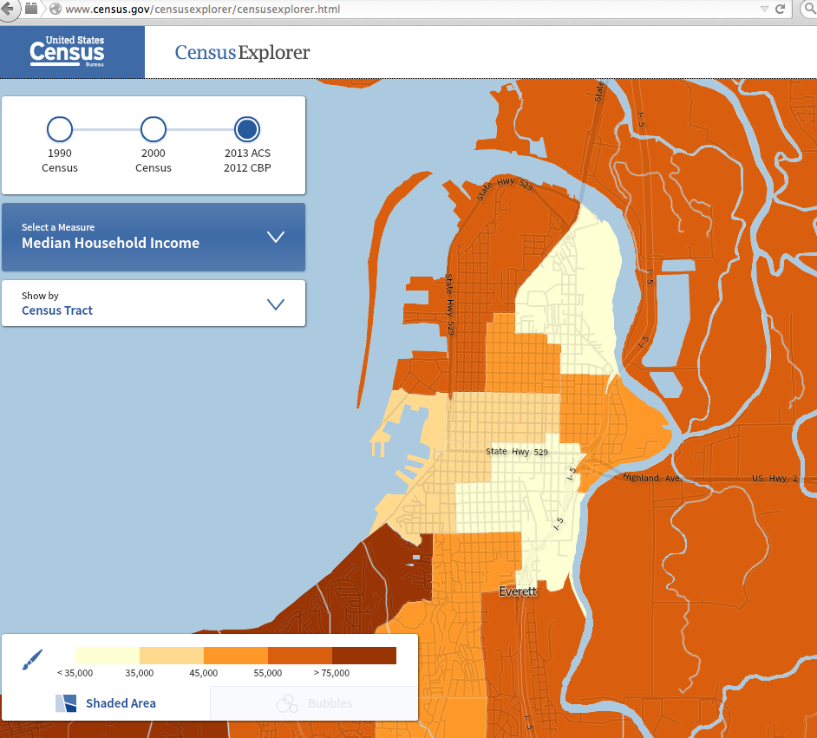

Residents in the Labor Force-Everett
This map represents the disparity in % in the labor force in the different geographic neighborhoods of Everett.

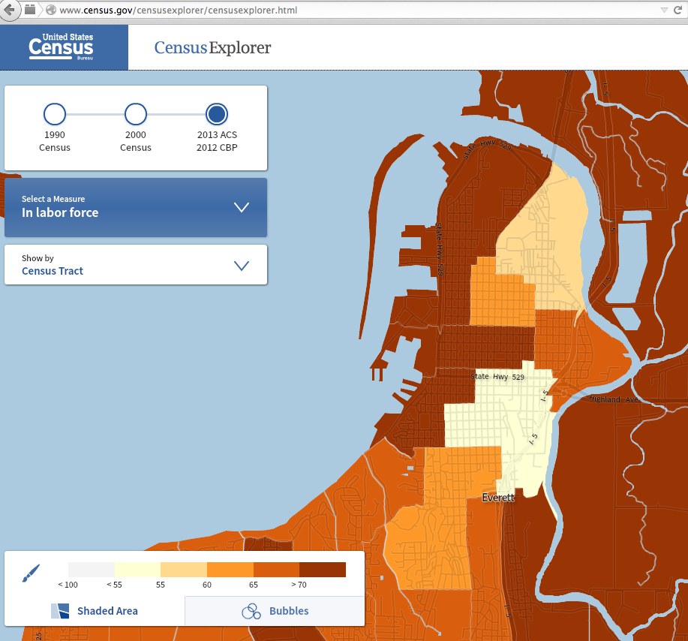

Residents 65 and over-Everett: This map represents the disparity in age distribution in the different geographic neighborhoods of Everett.
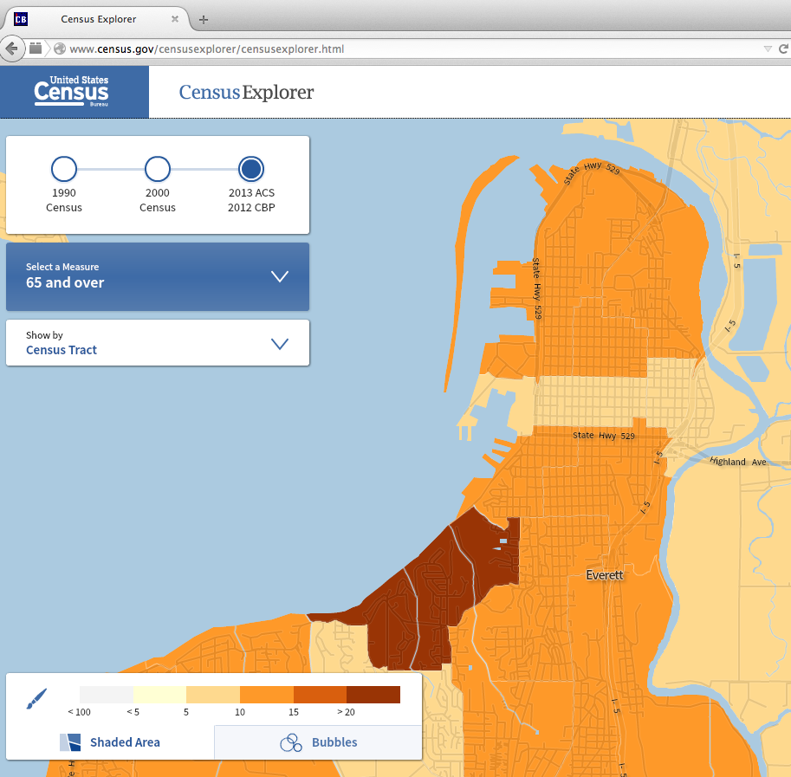

Appendix B-Electoral System for US Cities by Population
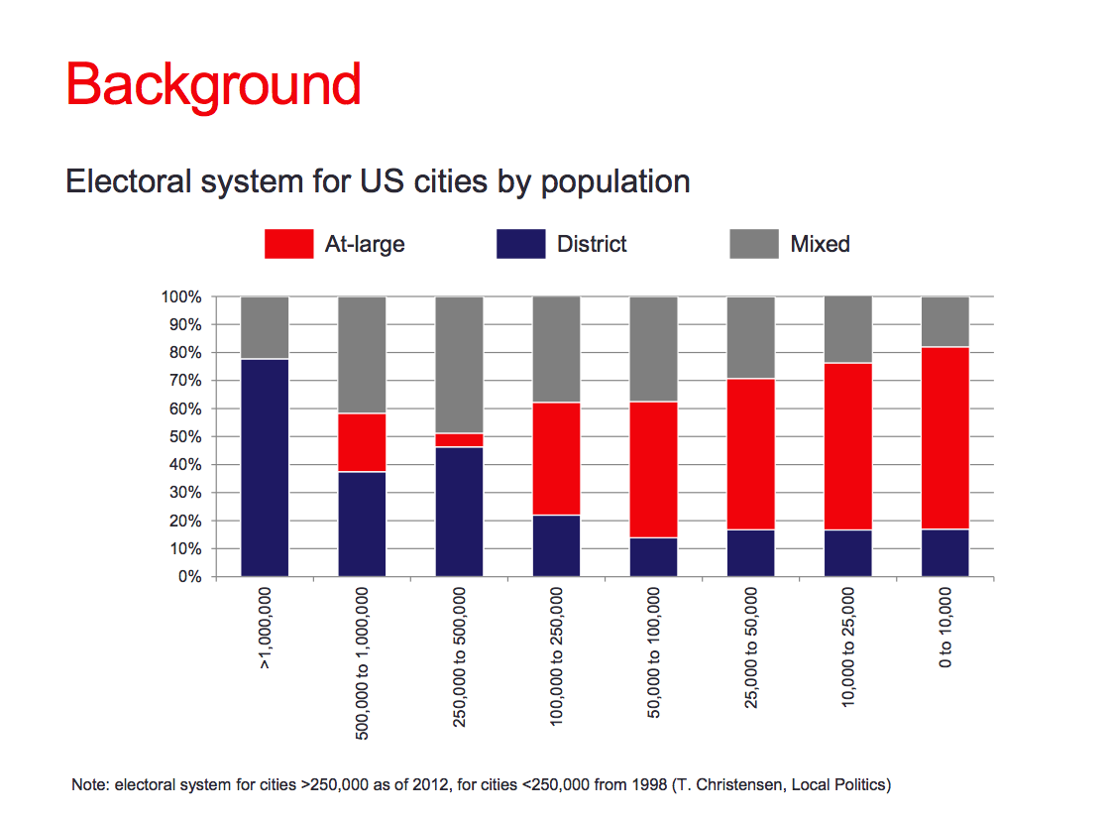
Chart from (Malinowski, 2013).

Appendix C-Proposed Mixed District Map-Prepared by Dr. Morrill
